FINAL YEAR PROJECT PROPORSAL

TOPIC:
DESIGN AND IMPLEMENTATION OF A BLOCKCHAIN-BASED ELECTRONIC VOTING SYSTEM

BY:
BOLU OMOLOLA
(⁠FPA/CS/23/3-0123)

SUPERVISED BY:
⁠MRS. AKIN OLAYEMI

SUBMITTED TO THE DEPARTMENT OF COMPUTER SCIENCE, FEDERAL POLYTECHNIC, ADO-EKITI
IN PARTIAL FULFILLMENT OF THE REQUIREMENTS FOR THE AWARD OF
HIGHER NATIONAL DIPLOMA IN COMPUTER SCIENCE

JUNE 2025

CERTIFICATION

DEDICATION
This project is dedicated to God almighty for guiding us and allowing the successful completion of the project. May all the glory and honor be to his Holy name, amen. We also dedicate this project to our guardians for endless and enormous support, effort and contributions in ensuring our success in this work and in our course of study, may God continue to bless them, amen.

ACKNOWLEDGMENT

TABLE OF CONTENTS

CERTIFICATION ii
DEDICATION iii
ACKNOWLEDGMENT iv
TABLE OF CONTENTS vi
Abstract 1
CHAPTER ONE 2
INTRODUCTION 2
1.1 BACKGROUND OF THE STUDY 2
1.2 STATEMENT OF THE PROBLEM 2
1.3 AIM AND OBJECTIVES OF THE STUDY 3
1.4 SCOPE OF THE STUDY 4
1.5 SIGNIFICANCE OF THE STUDY 4
1.6 DEFINITION OF TECHNICAL TERMS 5
CHAPTER TWO 7
LITERATURE REVIEW 7
2.1 INTRODUCTION 7
2.2 OVERVIEW OF ELECTRONIC VOTING 7
2.2.1 Essential Characteristics of a Secure E-Voting System 7
2.2.2 Requirements and Challenges in E-Voting 8
2.3 THE RISE OF BLOCKCHAIN IN E-VOTING 8
2.3.1 Blockchain as a Potential Solution 8
2.3.2 Persisting Challenges and Research Gaps 9
2.4 RECENT APPROACHES AND ARCHITECTURES 9
2.5 IDENTIFIED GAPS AND LIMITATIONS IN CURRENT RESEARCH 10
2.6 CONCEPTUAL FRAMEWORK 10
2.7 SUMMARY 11
CHAPTER THREE 12
SYSTEM ANALYSIS AND DESIGN 12
3.0 INTRODUCTION 12
3.1 RESEARCH METHODOLOGY 12
3.2 DATA COLLECTION METHOD 12
3.3 SYSTEM ANALYSIS 13
3.3.1 ANALYSIS OF THE CASE STUDY 13
3.3.2 WEAKNESSES OF THE PRESENT SYSTEM 13
3.3.3 SYSTEM JUSTIFICATION 14
3.4 ANALYSIS OF THE PROPOSED SYSTEM 14
3.4.1 Input Analysis 14
3.4.2 Process Analysis 15
3.4.3 Output Analysis 15
3.4.4 Benefits of the Proposed System 15
3.5 SYSTEM DESIGN 16
3.5.1 Architecture Diagram of the Proposed System 16
3.6 FUNCTIONALITY OF THE SYSTEM (USE CASE DIAGRAM) 17
CHAPTER FOUR 18
PROGRAMMING, IMPLEMENTATION AND DOCUMENTATION 18
4.1 INTRODUCTION TO PROGRAMMING CONCEPT 18
4.1.1 SOFTWARE METHODOLOGY 18
4.2 IDENTIFYING AND UNDERSTANDING THE PROBLEM 19
4.2.1 PROGRAM DESIGN 19
4.2.2 CODING 20
4.2.3 DEBUGGING 20
4.2.4 TESTING 20
4.2.5 DOCUMENTATION 21
4.3 DEVELOPMENT LANGUAGES AND TOOLS USED 21
4.4 JUSTIFICATION OF PROGRAMMING LANGUAGES USED 21
4.5 TESTING 22
4.7 PRINT SCREEN OF INTERFACES 22
4.7.1 ADMIN INTERFACES 22
4.7.2 VOTER INTERFACES 25
4.7.3 SMART CONTRACT DEPLOYMENT INTERFACE (OPTIONAL BUT RECOMMENDED) 29
4.7.4 META MASK TRANSACTION PROMPT 30
4.8 SYSTEM REQUIREMENTS 30
4.8.1 Hardware Requirements 30
4.8.2 Software Requirements 31
4.9 CHANGEOVER STRATEGY 32
CHAPTER FIVE 33
SUMMARY, CONCLUSION AND RECOMMENDATIONS 33
5.1 SUMMARY 33
5.2 CONCLUSION 33
5.3 RECOMMENDATIONS 34

Abstract
Democratic governance depends on secure, transparent, and trustworthy electoral systems. Yet traditional voting methods and even some modern electronic voting systems remain vulnerable to fraud, inefficiencies, and public skepticism, particularly in developing countries. Centralized e-voting solutions, while addressing some logistical challenges, introduce risks such as hacking, manipulation, and a lack of verifiability, further eroding voter confidence. This study proposes a blockchain-based electronic voting system as a transformative alternative, leveraging decentralization, immutability, and cryptographic security to enhance electoral integrity. By design, the system ensures voter anonymity, prevents tampering and duplicate voting, and enables real-time, auditable results without compromising privacy. Additionally, it reduces operational costs and logistical burdens while increasing accessibility and public trust. Through this research, we demonstrate how blockchain technology can revolutionize electoral processes, offering a scalable, secure, and transparent framework for modern democratic governance.

CHAPTER ONE

INTRODUCTION

1.1 BACKGROUND OF THE STUDY
Democratic governance is anchored on the credibility, transparency, and integrity of electoral processes. Paper-based voting has been the predominant method for decades, but it increasingly reveals critical flaws. These include logistical inefficiencies, high operational costs, ballot manipulation, voter suppression, and heightened risks of fraud and human error (Zhang et al., 2021). Such limitations become more pronounced in large-scale elections, where low voter turnout, long queues, and disputes over results frequently undermine public confidence.
Electronic voting (e-voting) was introduced to address some challenges, such as accelerating vote tallying, improving accessibility, and reducing manual counting errors. However, most centralized e-voting systems continue to suffer from vulnerabilities associated with single points of failure, such as central servers, proprietary software, and limited auditability. These weaknesses expose elections to insider threats, server compromise, and diminished public trust.
Recent research has therefore focused on the integration of blockchain technology with advanced cryptographic techniques including homomorphic encryption and zero-knowledge proofs to create tamper-evident and auditable bulletin boards while preserving voter privacy and verifiability (R. O. Isah et al., 2024; S. A. Alizadeh et al., 2023). Blockchain's decentralization, immutability, and cryptographic guarantees can significantly enhance transparency and resistance to tampering. Blockchain can enable end-to-end verifiability without compromising ballot secrecy when combined with privacy-preserving protocols.
As a result, blockchain technology is increasingly recognized as a promising foundation for secure and trustworthy voting systems. By recording votes as tamper-proof transactions on a distributed ledger, blockchain ensures that ballots are counted exactly as cast, while mechanisms such as zero-knowledge proofs safeguard voter anonymity (Li et al., 2023; Wu et al., 2023).
This project explores the design and implementation of a blockchain-based electronic voting system to reinforce democratic governance. The proposed system seeks to guarantee one-person-one-vote accuracy, uphold voter anonymity, and enable real-time result collation. Furthermore, its scalability allows deployment across diverse contexts from local community elections to national referendums at comparatively low infrastructure costs. Ultimately, blockchain-based e-voting can redefine electoral integrity by combining transparency with secure cryptographic methods, enhancing public trust, citizen participation, and verifiable accountability in democratic processes.

1.2 STATEMENT OF THE PROBLEM
Conventional voting systems, whether paper-based or centralized electronic variants, are plagued by persistent problems that undermine democratic principles. Paper-based systems are inherently vulnerable to physical manipulation, such as ballot-box stuffing, and suffer from significant logistical burdens, slow result tabulation, and potential disenfranchisement of voters in remote areas (Sari & Pratama, 2021). While electronic voting machines (EVMs) and online portals attempt to address these issues, they often introduce a new set of risks centered around their centralized architecture. These systems create single points of failure that are attractive targets for cyber-attacks, insider manipulation, and software malfunctions, with no practical mechanism for voters to independently audit the outcome (Yeh et al., 2024).
The core problem, therefore, is the absence of a voting system that simultaneously guarantees:
- Security and Immutability: Protection against tampering, double-voting, and data alteration.
- Transparency and Verifiability: Allowing any stakeholder to audit the election process and results without compromising secrecy.
- Voter Privacy: Ensuring that the choices of individual voters remain anonymous and unlinkable to their identity.
- Accessibility and Efficiency: Reducing logistical barriers and costs while accelerating the tallying process.
This research addresses this problem by proposing a blockchain-based electronic voting system designed to mitigate these vulnerabilities through decentralization and cryptographic verifiability.

1.3 AIM AND OBJECTIVES OF THE STUDY
The aim of this study is to design and implement a secure, transparent, and decentralized prototype of an electronic voting system leveraging blockchain technology to mitigate the inefficiencies and vulnerabilities inherent in traditional and centralized e-voting systems.
To achieve this aim, the following objectives have been defined:
- To conduct a comprehensive review of recent literature on blockchain architectures, consensus mechanisms, and cryptographic protocols applicable to e-voting systems.
- To analyze the limitations of existing e-voting systems and identify how a decentralized blockchain model can address these gaps, particularly in security, verifiability, and trust.
- To design a system architecture for a permissioned blockchain-based e-voting system that ensures voter authentication, vote secrecy via encryption, and immutable transaction recording.
- To develop a functional prototype implementing core voting smart contracts on a suitable blockchain framework (e.g., Ethereum, Hyperledger Fabric) to demonstrate vote casting, tallying, and verification.
- To evaluate the prototype against key performance metrics, including security, anonymity, scalability, and cost, and to discuss its applicability for small-scale elections.

1.4 SCOPE OF THE STUDY
This study is scoped to the design and implementation of a prototype blockchain-based e-voting system. The development and testing will be tailored to the context of small-scale elections, such as those within university campuses, local community organizations, or corporate settings.
The functional scope includes:
- Voter registration and identity verification within a controlled environment.
- Secure and anonymous vote casting using cryptographic techniques.
- Tamper-proof recording of vote transactions on a simulated or private blockchain network.
- Transparent and verifiable tallying of results through automated smart contracts.
This study will exclude:
- Large-scale national election deployment and its associated complexities (e.g., nationwide voter registration integration).
- The implementation of advanced biometric authentication systems.
- A comprehensive legal or regulatory analysis of the adoption of blockchain voting in national jurisdictions.
- Quantum-resistant cryptography, though its importance will be acknowledged as a future consideration.

1.5 SIGNIFICANCE OF THE STUDY
This study holds significance for both academic research and practical applications in the modernization of electoral systems through blockchain technology. By designing and implementing a blockchain-based electronic voting prototype, it contributes to the ongoing evolution of secure, transparent, and efficient electoral processes, particularly in small-scale elections.
The contributions of this study are multifold:
- Enhanced Security: Blockchain technology ensures that votes are securely stored, encrypted, and resistant to manipulation or tampering.
- Transparency and Trust: Since blockchain records are immutable, election outcomes can be independently verified, thereby fostering public confidence in the process.
- Voter Anonymity and Privacy: The system balances anonymity with verifiability, ensuring that individual votes remain private while aggregate results are auditable.
- Academic Contribution: The study adds to the growing body of literature (2021–2025) on blockchain applications beyond cryptocurrency, specifically by evaluating implementable e-voting architectures and analyzing trade-offs between consensus mechanisms (e.g., Proof-of-Authority vs. Raft).
- Technical Demonstration: The developed prototype provides a proof-of-concept, showcasing how smart contracts can automate voting procedures with minimal human intervention.
- Cost and Time Efficiency: Compared to traditional paper-based systems, blockchain voting reduces the need for physical infrastructure, manual counting, and administrative overhead.
- Scalability and Future Directions: Although designed for small-scale elections, the system’s architecture provides a foundation for expansion to larger contexts while also identifying open challenges such as scalability, voter coercion resistance, and regulatory adoption.
Ultimately, this study offers both a conceptual framework and a technical demonstration that can guide policymakers, system developers, and researchers in leveraging emerging technologies to improve the security and reliability of electoral systems.

1.6 DEFINITION OF TECHNICAL TERMS
Blockchain: A distributed ledger where transactions are recorded in cryptographically linked blocks replicated across multiple nodes in a peer-to-peer network.
Blocks: Data structures that store a batch of transactions, linked together in chronological order to form a blockchain.
Bitcoin: A decentralized digital currency that operates on a blockchain, where transactions are verified by a consensus mechanism without a central authority.
Consensus Mechanism: A protocol by which nodes in a blockchain network agree on the validity of transactions and the state of the ledger (e.g., Proof of Work, Proof of Stake, Delegated Proof of Stake).
Cryptocurrency: A digital currency that uses cryptographic techniques for secure transactions and operates on decentralized blockchain networks.
Cryptography: The science of encoding and decoding information to ensure data confidentiality, integrity, and authenticity.
Decentralization: The distribution of control and decision-making across a network rather than a single central authority.
Delegated Proof of Stake (DPoS): A consensus mechanism where stakeholders elect delegates to validate transactions and maintain the blockchain, improving efficiency and scalability.
Ethereum: An open-source, decentralized blockchain platform that supports smart contracts and decentralized applications (dApps).
Homomorphic Encryption: An encryption method that allows computations to be performed on encrypted data, producing results that remain encrypted and can be decrypted to reveal the correct output.
Hyperledger Fabric: A modular, permissioned blockchain framework designed for enterprise use, supporting plug-and-play components for identity management, consensus, and smart contracts.
Ledger: A consensually shared database that is synchronized across multiple sites or participants, recording transactions immutably.
Mining: The computational process of validating and adding new transactions to a blockchain, typically associated with Proof-of-Work blockchains such as Bitcoin.
Node: Any computer or device that participates in a blockchain network by validating transactions, storing ledger data, or relaying information.
Smart Contract: A self-executing contract stored on the blockchain, where predefined terms are automatically enforced once conditions are met.
Zero-Knowledge Proof (ZK): A cryptographic method that allows one party to prove knowledge of certain information without revealing the information itself.

CHAPTER TWO

LITERATURE REVIEW

2.1 INTRODUCTION
This chapter presents a critical review of existing literature relevant to the design and implementation of a blockchain-based electronic voting system. The purpose is to synthesize recent research, identify prevailing architectures, cryptographic techniques, and consensus mechanisms, and highlight the limitations and gaps in current approaches. This review establishes the theoretical and conceptual foundation for this project, justifying the need for a novel implementation that addresses identified challenges such as scalability, voter privacy, and practical deployment.

2.2 HISTORICAL BACKGROUND
In Nigeria, the conventional voting system has long been characterized by centralization and a multitude of intermediaries. During elections, voters are required to submit their identification documents to third-party individuals, often comprising election administrators or volunteers. Only after their identities have been verified by these third parties are voters granted permission to cast their ballots. This process involves using indelible ink to mark their preferred candidates on a physical document. Once completed, these documents are placed inside sealed envelopes and stored in closed containers until the voting process concludes and the ballots are counted.
This traditional voting method, as practiced in Nigeria, presents several vulnerabilities that can be exploited for electoral malpractice. For instance, representatives can potentially permit ineligible voters to participate, and there exists a risk of tampering with the ballot boxes. These inherent weaknesses erode trust in the entire electoral process and pose substantial risks to the integrity of the process. Consequently, the Nigerian electoral system demands a robust transformation to incorporate elements of security, transparency, and data preservation, while mitigating the risk of data loss.
Blockchain can solve the many problems discovered in these early attempts at online voting. A blockchain-based voting application does not concern itself with the security of its Internet connection, because any hacker with access to the terminal will not be able to affect other nodes. Voters can effectively submit their vote without revealing their identity or political preferences to the public. Officials can count votes with absolute certainty, knowing that each ID can be attributed to one vote, no fakes can be created, and that tampering is impossible.

2.3 ELECTIONS
Elections are a fundamental component of democratic societies and are used to determine who will hold public office, make legislative decisions, or lead a group. The primary objective of an election is to select authentic representatives to govern a nation or organization, thus upholding the principles of democracy within administrative structures. Ensuring the security, transparency, and veracity of the electoral process is of utmost importance.

2.3.1 TYPES OF ELECTIONS
There are different types of election conducted each based on different contexts to select representatives or decide on specific issues. Electoral systems and types of elections can vary widely across different countries, regions, and political structures, each serving specific purposes in the democratic process. Here are some types of elections:
- General Elections: These are the standard elections held in a country to choose representatives for legislative bodies, such as members of parliament or congress, the president, or other key government officials. General elections often involve multiple positions being contested simultaneously. ("Elections" by David Butler and David Marquand (2004))
- Primary Elections: In countries like the United States, primary elections are held by political parties to select their candidates for the general election. Voters choose from within the same party to decide who will represent their party in the main election. ("The American Voter" by V.O. Key, Jr. (1966))
- Local Elections: These elections focus on selecting officials at the local level, such as mayors, city council members, school board members, or other positions that primarily affect a specific locality or region. ("Local Elections" by Robert P. Bretz and John C. Myers (2018))
- By-Elections (Special Elections): By-elections are a term used for special elections in some countries, particularly in the Commonwealth of Nations. By-elections occur to fill a political office that has become vacant between general elections. They might be triggered due to resignation, death, or disqualification of the incumbent. Only the affected area votes in a by-election. ("By-Elections in British Politics: A Study of Electoral Continuity and Change" by Peter Dorey (1997))

- Referendums and Initiatives: These are direct votes by citizens on a particular policy issue or proposed law. Referendums allow voters to directly decide on a specific question, while initiatives enable citizens to propose new laws or amendments to existing laws. ("Direct Democracy: Law and Practice" by Michael Gallagher and Susan Park (2011), "The Initiative in California: A Study of Direct Democracy" by James W. Singer (2004)
- Runoff Elections: In cases where no candidate secures the required majority in the initial election, a runoff or second-round election is held between the top candidates to determine the final winner. ("Runoff Elections: A Comparative Study of Electoral Systems" by Matthew G. Stevens and David Van Cott (2008))
- Proportional Representation Elections: Proportional representation (PR) constitutes an electoral framework where a party's seat allocation corresponds proportionally to its received votes. This signifies that if a party garners 20% of the votes, it secures 20% of the legislative seats. PR systems find application in numerous countries globally, including Germany, Norway, and Sweden. Their fundamental objective is to align the number of seats a party attains in an election with the percentage of votes they garner. Diverse variations of proportional representation systems are implemented across different nations. ("Proportional Representation" by Andrea Mattozzi (2019))
- Electoral College Elections: In some countries, including the United States, the president is not directly elected by the popular vote but through an electoral college system. The electoral college is a body of electors, each of whom is appointed by a state's legislature. The number of electors each state gets is based on its population. Electors from each state vote for the president based on the popular vote in their state. The candidate who receives a majority of electoral votes wins the presidency. ("The Electoral College: How It Works and Why We Need to Change It" by David C. Huckabee (2016))
- Nonpartisan Elections: These elections don't involve political parties. Candidates run as individuals, and their party affiliation isn't part of the voting process. ("Nonpartisan Elections: A Comparative Study" by Richard W. Gable and John C. Holmes (1985))

2.4 OVERVIEW OF ELECTRONIC VOTING
Electronic voting (e-voting) is broadly defined as any voting method that uses electronic means to aid the casting and counting of votes. When properly implemented, it holds the promise of enhancing democratic processes by increasing accessibility, accelerating result tabulation, and reducing certain avenues of fraud associated with manual systems (Zhang et al., 2021). Estonia remains the global pioneer, having successfully implemented internet voting (i-voting) in national elections since 2005, providing a long-term case study for remote electronic voting (Krips & Willemson, 2024).
However, traditional and centralized e-voting systems are fraught with challenges. A primary criticism is their lack of transparency and end-to-end verifiability (E2E-V). Voters and independent auditors must place absolute trust in the election administrators and the proprietary software, as there is no feasible way to verify that a vote was recorded as cast and counted as recorded (Benabdallah et al., 2023). This creates a critical single point of failure; compromising the central server can compromise the entire election (Yeh et al., 2024).

2.4.1 Essential Characteristics of a Secure E-Voting System
Recent literature consolidates the following as non-negotiable requirements for any credible e-voting system (Li et al., 2023; Wu et al., 2023):
- Eligibility: Only registered voters can vote.
- Unreusability (Prevention of Double-Voting): Each eligible voter can vote only once.
- Privacy/Anonymity: A vote cannot be linked to the voter who cast it.
- Accuracy: No vote can be altered, removed, or invalidated maliciously.
- Verifiability:
  - Individual Verifiability: A voter can verify that their own vote was recorded correctly.
  - Universal Verifiability: Anyone can verify that all recorded votes were counted correctly.
- Immutability: Once cast, a vote cannot be changed.
- Fairness: Partial results cannot be known before the election concludes, to prevent influencing voters.
- Robustness: The system should withstand a reasonable proportion of faulty or malicious participants.

2.4.2 Requirements and Challenges in E-Voting
Beyond essential characteristics, the practical deployment of e-voting systems encounters persistent challenges. Scalability remains problematic, as centralized infrastructures can be overloaded during high-turnout elections. Security vulnerabilities, including insider attacks and malware, undermine trust (Ghazali et al., 2022). Furthermore, ensuring voter anonymity while maintaining accountability creates cryptographic complexities. Legal and regulatory ambiguities compound these challenges, as many jurisdictions have not yet developed frameworks for e-voting audits and dispute resolution (Krips & Willemson, 2024).

2.5 THE RISE OF BLOCKCHAIN IN E-VOTING
Blockchain technology has emerged as a foundational solution to the core challenges of traditional e-voting. Its inherent properties decentralization, immutability, transparency, and cryptographic security align closely with the requirements for trustworthy elections (Zhang et al., 2021).
A blockchain is a distributed, append-only digital ledger maintained by a network of nodes without a central authority. Transactions are grouped into blocks, which are cryptographically linked to the previous block, creating a chain that is computationally infeasible to alter retroactively. This structure provides a transparent and tamper-evident record of all votes cast (Yeh et al., 2024).
Smart contracts self-executing code deployed on the blockchain are pivotal to automating the electoral process. They can encode the rules of an election (e.g., voter eligibility, vote casting, and tallying), ensuring execution without human intervention or bias, thereby enhancing trust in the process (Benabdallah et al., 2023).

2.5.1 Blockchain as a Potential Solution
Blockchain addresses several of the previously identified weaknesses of e-voting. Its decentralized ledger eliminates reliance on a single authority, reducing the risk of manipulation by insiders. Immutability guarantees that votes, once cast, cannot be retroactively altered, enhancing election integrity (Khan et al., 2022).
Another significant advantage is end-to-end verifiability. Voters can confirm that their ballots were included in the final tally without revealing their identity, thereby balancing transparency with privacy (Al-Debagy & Martinek, 2021). Smart contracts further automate critical functions such as eligibility checks and vote counting, minimizing human interference (Zhou et al., 2023).
Permissioned blockchains strike a balance between decentralization and efficiency. By restricting block validation to trusted institutions (e.g., electoral commissions, universities), they achieve higher scalability while retaining auditability (Rana et al., 2024).

2.5.2 Persisting Challenges and Research Gaps
Despite its promise, blockchain is not a panacea for e-voting. Scalability remains a limitation, as existing blockchain platforms struggle to handle millions of concurrent voters (Ramezan et al., 2022). Consensus mechanisms such as PoW or PoS present trade-offs between efficiency, fairness, and resilience to collusion.
Privacy vs. transparency also poses a paradox. While blockchain ensures a tamper-proof public record, maintaining absolute voter anonymity without undermining verifiability is an ongoing research challenge (González et al., 2023). Furthermore, blockchain systems are susceptible to external threats such as denial-of-service attacks and require complementary security mechanisms.
On the socio-legal side, regulatory frameworks have not kept pace with technological advances, raising questions of compliance, auditability, and voter inclusion (Shuaib et al., 2023). Moreover, digital divides in connectivity and literacy risk excluding marginalized groups, raising ethical concerns.
These unresolved gaps justify continued interdisciplinary research into blockchain-enabled elections, particularly in areas such as cryptographic privacy preservation, usability, and legal integration.

2.6 RECENT APPROACHES AND ARCHITECTURES
Recent research has moved beyond theoretical proposals to concrete architectures and prototypes, primarily focusing on permissioned blockchains and advanced cryptography to balance performance with privacy.
- Privacy-Preserving Techniques: The use of Zero-Knowledge Proofs (ZKPs), particularly zk-SNARKs, has become a dominant theme. ZKPs allow a voter to prove that their encrypted vote is valid (i.e., for a legitimate candidate) without revealing the vote itself, satisfying both privacy and universal verifiability (Li et al., 2023; Wu et al., 2023). Homomorphic encryption is also explored for enabling tallying to occur on encrypted votes, though it often faces computational overhead challenges (Almarzouqi et al., 2022).
- Consensus Mechanisms: Research consensus indicates that energy-intensive Proof-of-Work (PoW) is unsuitable for e-voting. Recent systems favor efficient, finality-based algorithms like Proof-of-Authority (PoA) or Practical Byzantine Fault Tolerance (PBFT), where trust is placed in a consortium of authorized entities (e.g., election committees, judicial bodies, universities) to validate transactions quickly and without fees (Krips & Willemson, 2024; Yeh et al., 2024).
- Hybrid On-Chain/Off-Chain Storage: To address scalability, a common architectural pattern stores only the cryptographic hash or commitment of the vote on-chain. The actual encrypted vote is stored in an off-chain decentralized storage system like the InterPlanetary File System (IPFS), ensuring data integrity while minimizing blockchain bloat (Benabdallah et al., 2023).
- Case Studies: Several recent pilot implementations offer valuable insights. Sari and Pratama (2021) documented a successful university election using a private Ethereum network, highlighting high transparency but also challenges in voter onboarding. Likewise, studies have proposed frameworks for small-scale organizational voting utilizing Hyperledger Fabric, emphasizing its modularity and access control features (Awotunde et al., 2023).

2.7 IDENTIFIED GAPS AND LIMITATIONS IN CURRENT RESEARCH
Despite significant advancements, a review of recent literature reveals persistent challenges:
- Scalability for National Elections: While effective for small-scale use, the throughput of many proposed systems remains a barrier to national deployment with millions of voters (Yeh et al., 2024).
- Voter Anonymity vs. Accountability: Severing the link between a voter's identity and their public key without enabling double-voting remains a complex cryptographic and logistical challenge (Wu et al., 2023).
- Usability and Key Management: The user experience of managing private keys and interacting with blockchain wallets is still a significant hurdle for non-technical voters. The irreversible consequence of a lost private key is a critical design flaw from a user-centric perspective (Krips & Willemson, 2024).
- Coercion Resistance: Remote blockchain voting systems can be vulnerable to coercion, as a voter may be forced to prove how they voted under duress, a problem mitigated by the physical privacy of a voting booth (Zhang et al., 2021).
- Regulatory and Legal Hurdles: Most research focuses on the technical implementation, with less attention paid to the integration with existing electoral laws and standards for auditability (Awotunde et al., 2023).

2.8 CONCEPTUAL FRAMEWORK
The conceptual framework for this project is built upon the synthesis of recent research, focusing on a permissioned blockchain architecture.
- Core Components: The system will comprise: 1) a Voter Authentication Module (off-chain), 2) a Smart Contract Layer governing election rules, 3) a Permissioned Blockchain Network (e.g., a PoA Ethereum chain or Hyperledger Fabric) for immutable recording, and 4) a User Interface for voter interaction.
- Linking Concepts: Voter identity will be verified off-chain and then granted access to a pseudonymous voting address. The smart contract will enforce eligibility and unreusability. Votes will be encrypted (using ZKPs where feasible) before being submitted as transactions. The decentralized consensus of the authorized nodes will ensure the immutability and transparency of the tally, which will be automatically computed and published by the smart contract.
- Addressing Gaps: This framework explicitly addresses the verifiability and immutability gaps of traditional e-voting. It tackles the performance issues of pure PoW systems by choosing a permissioned consensus model suitable for a controlled electoral environment.

2.9 SUMMARY
The literature confirms that blockchain technology offers a potent solution to the enduring problems of electoral transparency and trust. Recent advancements have converged on architectures utilizing permissioned blockchains, smart contracts, and advanced cryptography like ZKPs to create secure, verifiable, and efficient e-voting prototypes. However, key challenges in scalability, ultimate voter anonymity, user experience, and legal compliance remain open research questions. This project will contribute to this field by designing and implementing a prototype that addresses the practicality of these solutions for small-scale elections, with a specific focus on a robust and user-aware design.

CHAPTER THREE

SYSTEM ANALYSIS AND DESIGN

3.0 INTRODUCTION
This chapter discusses the system architecture, research methodology, and analysis of both the existing and proposed systems. It highlights the data collection approach, tools, and techniques employed in developing the blockchain-based electronic voting system. The chapter further describes the analytical framework that guided the design and implementation process, focusing on system requirements, architecture, user interface design, and data management strategies that ensure integrity, transparency, and efficiency in electoral processes.

3.1 RESEARCH METHODOLOGY
This section discusses the methods, materials, and approach used in developing the proposed blockchain-based electronic voting system. The study adopts a system development-based research methodology, integrating software engineering principles with blockchain experimentation to enhance security, transparency, and accessibility in electronic voting.
The Waterfall model was adopted as the software development methodology. This model provides a structured and sequential approach, where each phase depends on the deliverables of the previous one. Its linear progression ensures systematic planning, design, implementation, testing, and deployment, making it suitable for developing a secure and verifiable blockchain voting system.
The Waterfall model followed these phases for this system:
- Problem Identification and Requirement Gathering
  - Analyzing challenges of traditional voting systems, such as ballot tampering, fraud, and lack of transparency.
  - Defining the need for a decentralized, trustless blockchain-based voting platform.
- System Design
- Developing the system architecture to define relationships between the smart contract, blockchain network, and web interface.
- Creating design artifacts such as wireframes, flowcharts, and UML diagrams to guide development.
- Coding / Implementation
  - Writing the Solidity smart contract (ElectionManager.sol) to manage elections, candidates, and votes.
  - Building the frontend using React.js integrated with Ethers.js for blockchain interaction.
- Debugging
  - Resolving integration issues between the frontend and the smart contract via MetaMask.
  - Correcting errors in contract logic and UI functionality.
- Testing
  - Performing unit tests for smart contract functions.
  - Conducting integration tests for the full workflow (React–MetaMask–Contract interactions).
- Deployment and Documentation
  - Deploying the smart contract to the Ethereum test network using Hardhat.
  - Hosting the web interface and preparing technical documentation, user guides, and developer setup instructions.
This sequential methodology ensures clear planning, structured development, and systematic testing, resulting in a robust blockchain voting system with secure, transparent, and verifiable election processes.
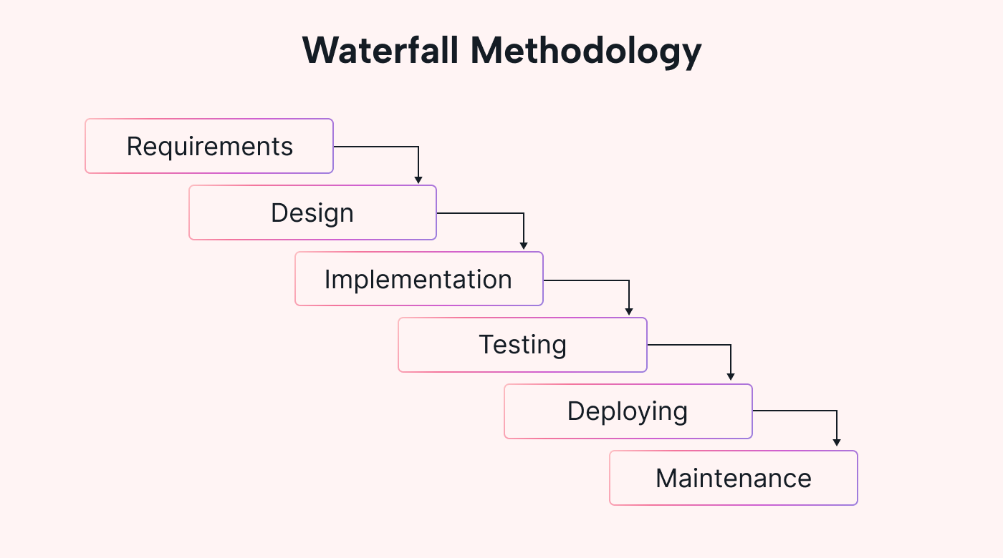
Figure 3.1 Waterdall SDLC diagram

3.2 DATA COLLECTION METHOD
Due to the technical nature of this project, secondary data sources formed the primary basis of information gathering. Sources included peer-reviewed journal articles, white papers, and technical documentation related to blockchain technology, smart contracts, cryptographic systems, and electronic voting models. Materials were retrieved from reputable databases such as IEEE Xplore, Springer, and Google Scholar. No primary data (e.g., interviews or questionnaires) were collected because the focus of this project is on system design and implementation as a proof of concept.

3.3 SYSTEM ANALYSIS
System analysis involves understanding the existing voting process, identifying challenges, and defining functional and non-functional requirements for the proposed blockchain solution. It focuses on improving security, transparency, and accessibility by eliminating intermediaries and manual processing.
Through analysis, the weaknesses of the traditional voting system were identified, and blockchain was selected as a suitable solution due to its decentralized, immutable, and transparent nature.

3.3.1 ANALYSIS OF THE EXISTING SYSTEM
Currently, voting in the Department of Computer Science (and many other departments) is conducted using paper ballots. Voters manually select their preferred candidates on paper forms, which are then collected and counted manually after the election period. While this process ensures a degree of anonymity, it suffers from inefficiencies, potential manipulation, and human error.
After the election, ballot boxes are transported to counting centers where officials and observers manually tally votes. This manual process is time-consuming, costly, and susceptible to tampering. Despite improvements, these traditional systems continue to exhibit significant weaknesses.

3.3.2 WEAKNESSES OF THE EXISTING SYSTEM
The current paper-based voting system suffers from the following challenges:
- Integrity Issues – The system relies heavily on the honesty of election officials, making it prone to manipulation and corruption.
- Accessibility – Students or voters outside the campus or those with physical limitations may find it difficult to access polling stations.
- High Cost – Printing, logistics, security, and staffing contribute to significant operational costs.
- Inefficiency – Manual counting and verification slow down result collation and introduce human errors.
- Security Threats – Ballot-box stuffing and tampering remain persistent threats.
- Violence – Physical polling often results in unrest or intimidation at polling centers.

3.3.3 SYSTEM JUSTIFICATION
Blockchain technology addresses these weaknesses through its decentralized, immutable, and transparent ledger structure. Every transaction (vote) is recorded on a public ledger, cryptographically secured, and cannot be altered once confirmed.
By leveraging blockchain:
- Voters gain confidence that votes are securely stored and cannot be tampered with.
- Transparency is achieved through a shared ledger visible to authorized users.
- Anonymity is maintained through the use of wallet addresses and cryptographic hashing.
This ensures a trustless system, where no single authority controls the election outcome.

3.4 ANALYSIS OF THE PROPOSED SYSTEM
The proposed system integrates blockchain with a web-based front end to create a secure, transparent, and verifiable electronic voting platform. Each voter is registered using their wallet address and matric number, ensuring a unique identity and enforcing the principle of “one voter, one vote.”
Votes are recorded as blockchain transactions, and each vote updates the corresponding candidate’s tally in real time. The system consists of three main entities:
- Admin – creates and manages elections, verifies voters, and adds candidates.
- Voters – register, get verified, and cast votes.
- Smart Contract – stores and enforces all election rules immutably.

3.4.1 Input Analysis
The inputs to the system include:
- Voter details: name, matric number, and wallet address.
- Election parameters: title, description, start and end time.
- Candidate details: name and unique ID.
- Vote choice: the candidate selected by the voter.
These inputs are collected through the web interface and stored in the smart contract (ElectionManager.sol) for secure processing on the blockchain.

3.4.2 Process Analysis
The main system processes include:
- Voter Registration: The user submits their name and matric number; the smart contract stores and maps it to their wallet address.
- Voter Verification: Admin verifies the voter, enabling voting access.
- Election Creation: Admin defines the election parameters and adds candidates.
- Voting: Verified voters cast votes, which are recorded immutably on-chain.
- Result Viewing: Anyone can view the election results transparently once voting ends.

3.4.3 Output Analysis
System outputs include:
- Election summaries and detailed candidate lists.
- Voter verification status.
- Real-time voting statistics and results.
These outputs are displayed on the web dashboard, providing transparency and easy monitoring.

3.4.4 Benefits of the Proposed System
- Transparency: All votes are visible on the blockchain ledger, preventing manipulation.
- Anonymity: Voter identities remain hidden through cryptographic wallet addresses.
- Security: Immutable smart contracts eliminate unauthorized access or vote alteration.
- Efficiency: Vote counting and result publication occur instantly.
- Individual Verifiability: Each voter can confirm that their vote is included in the final tally.
- Universal Verifiability: External observers or auditors can independently verify the election outcome using blockchain data.

3.5 SYSTEM DESIGN
The proposed system architecture is designed to create a decentralized, secure, and user-friendly electronic voting platform that integrates blockchain technology with a web-based interface. The architecture consists of three main components: the blockchain server, the web application backend, and the frontend interface.
The system leverages a public blockchain, meaning that anyone can serve as a node in the network, and no trust is required among participants. However, not every registered voter must operate as a blockchain node, and not every node functions as a voting device—there is a clear distinction between nodes and voter devices. This separation ensures scalability and efficiency without compromising decentralization.
Frontend Technologies
- HTML5: Defines the structure and layout of the web interface.
- CSS3 / Tailwind CSS: Handles responsive and modern user interface styling.
- JavaScript (React.js): Provides interactivity, wallet integration, and seamless communication with blockchain components.
Backend and Blockchain Stack
- Node.js: Manages server-side logic, API routing, and communication with the blockchain.
- Hardhat: Used for developing, testing, and deploying Ethereum-based smart contracts.
- Solidity (ElectionManager.sol): Defines all election-related logic, including candidate management, voter registration, and vote casting.
- Ethers.js: Bridges the React frontend with the deployed smart contract on the blockchain.

3.5.1 Architecture Diagram of the Proposed System
The architecture follows a three-layer design for modularity, scalability, and transparency:
- Presentation Layer (Frontend):
Handles user interactions, wallet connections, and input validation through a React-based interface.
- Application Layer (Smart Contract):
Implements the core election logic, manages state transitions, enforces voting rules, and emits blockchain events for transparency.
- Data Layer (Blockchain Network):
Serves as the immutable ledger where votes, election records, and voter details are securely stored and verifiable by all participants.
This layered structure ensures seamless integration between the frontend, backend, and blockchain components, promoting security, transparency, and decentralization in the overall system operation.
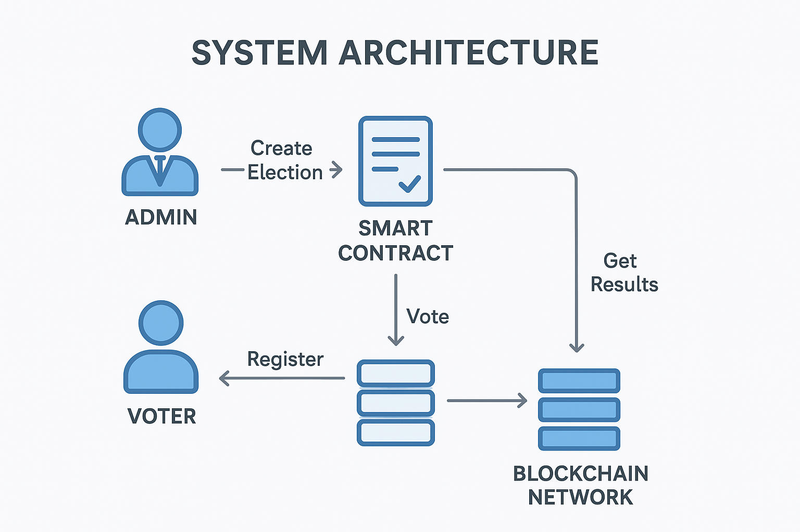
Figure 3.5.1: System Architecture

3.6 UML DIAGRAMS
The Unified Modeling Language (UML) is a standardized visual notation used to describe the structure and behavior of a system. It provides a clear representation of the system’s components, their interactions, and the relationships between different modules. UML diagrams are widely used in software engineering to improve understanding, design accuracy, and communication among developers.
In this study, UML diagrams are employed to represent both the system structure (through a general UML class/component diagram) and user interactions (through a use case diagram). Together, these diagrams serve as the foundation for translating conceptual design into practical implementation, helping to define who interacts with the system and how those interactions occur.
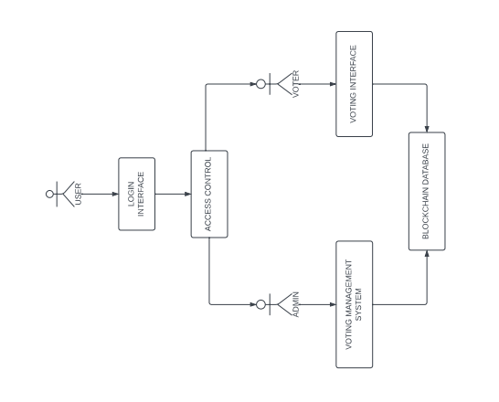
Figure 3.6: UML Diagram of the Proposed Blockchain-Based Voting System

3.6.1 USE CASE DIAGRAM
A Use Case Diagram visually depicts the interactions between users (actors) and the system. It plays a critical role in system design by defining how different users interact with system functions and by serving as a roadmap for developing and organizing the system’s structure.
Use Case Diagrams are particularly useful for identifying system requirements and clarifying user expectations. They help developers and stakeholders understand the scope of functionalities to be implemented.
The main elements of a Use Case Diagram include:
- Actors: External entities (users or systems) that interact with the application.
- Use Cases: Specific actions or services the system performs in response to an actor’s request.
The Use Case Diagram for the proposed blockchain-based electronic voting system illustrates the interactions between two primary actors the Voter and the Admin and the system’s core functionalities.

Actors and Use Cases:
Actor: Voter
Use Cases:
  - Register for Election
  - Cast Votes
  - Receive Hashed Votes
  - View Results
Actor: Admin
Use Cases:
- Create Elections
- Verify / Authenticate Candidates
- View Results

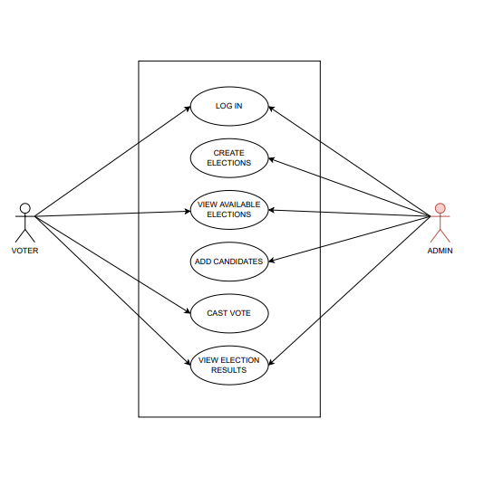
Figure 3.6.1: Use Case Diagram for the Voter and Admin

3.7 FLOWCHART FOR THE VOTING SYSTEM
These diagrams represent the algorithm used in the system for both voters and administrators. The flowchart for voters and admins of this system as shown in Figure 3.6 and Figure 3.7, respectively.
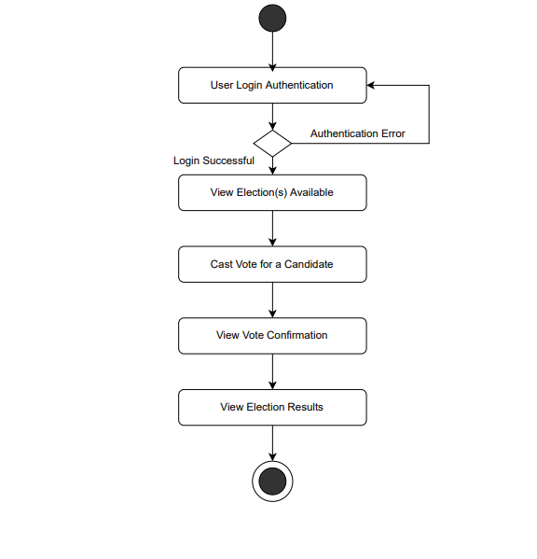
Figure 3.7.1 Flowchart Diagram for a voter

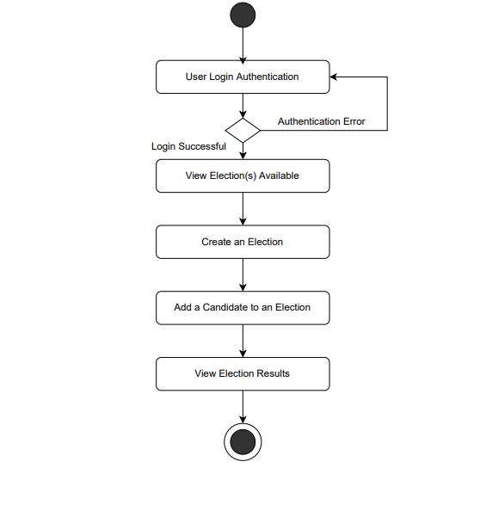
Figure 3.7.2: Flowchart Diagram for an admin

CHAPTER FOUR

PROGRAMMING, IMPLEMENTATION AND DOCUMENTATION

4.1 INTRODUCTION TO PROGRAMMING CONCEPT
Programming is the process of designing and building an executable computer program to accomplish a specific computational objective. It involves defining problems, analyzing requirements, generating algorithms, and implementing them in a suitable programming language. For this study, programming was centered around web-based decentralized application (DApp) development, combining blockchain smart contract logic with a user-friendly web interface.
The developed system a Blockchain-Based Electronic Voting System is implemented as a decentralized web application (DApp). It leverages blockchain technology to ensure security, transparency, and immutability of votes, while maintaining a web-accessible interface for both administrators and voters.
The application architecture is divided into three main components:
- Smart Contract Layer – written in Solidity and deployed via Hardhat on an Ethereum-compatible blockchain (e.g., localhost or testnet).
- Frontend Layer – developed with React.js, integrating MetaMask for wallet-based authentication and interaction with the blockchain.
- Backend/Build Tooling Layer – handled by Node.js, Ethers.js, and Hardhat, used for contract compilation, deployment, and communication.

4.2 PROGRAM DESIGN
Program design involves transforming user and system requirements into a logical and technical blueprint. The system is designed to support two primary user roles Admin and Voter each interacting with the system through distinct interfaces.

4.2.1 Input Screen Design
The input interface allows users to interact with the blockchain:
- Admin Interface:
- Create and manage elections.
- Add or remove candidates.
- Register and verify voters.
- Start or end elections.
- Voter Interface:
- Connect MetaMask wallet.
- Verify registration.
- View candidates and cast vote.

4.2.2 Output Screen Design
The output interface displays:
- Confirmation of successful transactions (e.g., vote submission).
- Election results automatically computed and fetched from the blockchain.
- Admin dashboards for election monitoring.

4.3 CODING
The system implementation integrates multiple technologies:
- Smart Contract Layer: The ElectionManager.sol contract written in Solidity (v0.8.19) defines core functionalities such as:
- Election creation, update, and deletion by the Admin.
- Candidate registration and vote counting.
- Voter registration, verification, and voting restriction logic.
- Read functions for election and candidate data.
- Development Environment: The contract was developed and deployed using Hardhat, which provides a local Ethereum network and testing framework.
- Frontend Layer: The interface was built with React.js and integrated with the Ethereum blockchain using Ethers.js and MetaMask.
Example core files include:
- useContract.js – custom React hook for contract connection.
- Login.jsx, AdminDashboard.jsx, and VotePage.jsx – React components managing user interaction.
Backend Utilities:
- Node.js for build automation.
- Ethers.js for contract interaction.
- React Hot Toast for user notifications.

4.4 DEBUGGING
During development, several integration challenges were encountered, including:
- Errors connecting MetaMask to Hardhat local network.
- Transaction rejection due to incorrect signer or unregistered voter.
- Contract event decoding issues during testing.
- Debugging involved:
- Using Hardhat’s stack trace and console logs.
- Validating wallet connections and permissions.
- Deploying contracts afresh after ABI updates.
- Testing with dummy accounts on the local blockchain network.

4.5 TESTING
Testing validated both the correctness of blockchain interactions and overall user workflows in the developed system. Two levels of testing were performed:
- Unit Testing
  - Focused on validating individual smart contract functions using Hardhat’s testing suite.
  - Ensured expected outputs from methods such as createElection(), registerVoter(), and vote().
- Integration Testing
  - Verified interactions between the React frontend, MetaMask wallet, and deployed smart contract.
  - Ensured that voters could only vote once and only when elections were active.
  - Confirmed that election results were correctly displayed after voting ended.
- Functional Testing
  - Ensured that all modules, including login, registration, voting, and result viewing, operated as intended.
- Security Testing
  - Verified that only registered voters could vote.
  - Ensured that votes were irreversible and securely recorded on the blockchain.
- Performance Testing
  - Assessed the DApp’s response time during blockchain transactions and UI updates.
All tests confirmed functional correctness, security, and smooth system operation, demonstrating that the system successfully provides a transparent, tamper-proof, and efficient electronic voting experience.

4.6 DOCUMENTATION
Documentation was prepared to guide both developers and users. It covers:
- Smart contract deployment steps using Hardhat.
- Environment setup (Node.js, React, MetaMask, and .env configuration).
- Admin and voter usage flow.
- System maintenance and extension guidelines.

4.7 DEVELOPMENT LANGUAGES AND TOOLS USED
Technology | Purpose
Solidity | Core blockchain smart contract programming language.
Hardhat | Development environment for compiling, testing, and deploying contracts.
React.js | Frontend library for building responsive UI components.
Node.js | Backend runtime and dependency management.
Ethers.js | Library for interacting with Ethereum blockchain from frontend.
MetaMask | Browser wallet used for transaction signing and authentication.
HTML, CSS, JavaScript | For UI structure, styling, and interactivity.
React Hot Toast | Notification feedback library.

4.8 JUSTIFICATION OF PROGRAMMING LANGUAGES USED
- Solidity: Provides an immutable and transparent way to record votes on the Ethereum blockchain, ensuring that no vote can be altered or deleted once cast.
- Hardhat: Simplifies smart contract compilation, deployment, and testing with a local Ethereum simulation environment.
- React.js: Offers a reactive, modular approach to building the web interface, ensuring smooth state management and dynamic updates.
- Node.js & Ethers.js: Allow asynchronous blockchain interactions and real-time updates of vote counts.
- MetaMask: Provides secure wallet-based authentication, ensuring only registered Ethereum addresses can participate.
The combination of these technologies ensures a secure, decentralized, and user-friendly application architecture.

4.9 SCREENSHOT OF INTERFACES
This section presents screenshots of the developed Blockchain-Based Electronic Voting System, highlighting the interfaces and functionalities of both the Admin and Voter modules. Each interface is briefly described to explain its purpose and function within the system.

4.9.1 ADMIN INTERFACES
(a) Admin Login / Wallet Connection Page
This page allows the admin to connect their MetaMask wallet to the DApp before accessing admin functionalities.
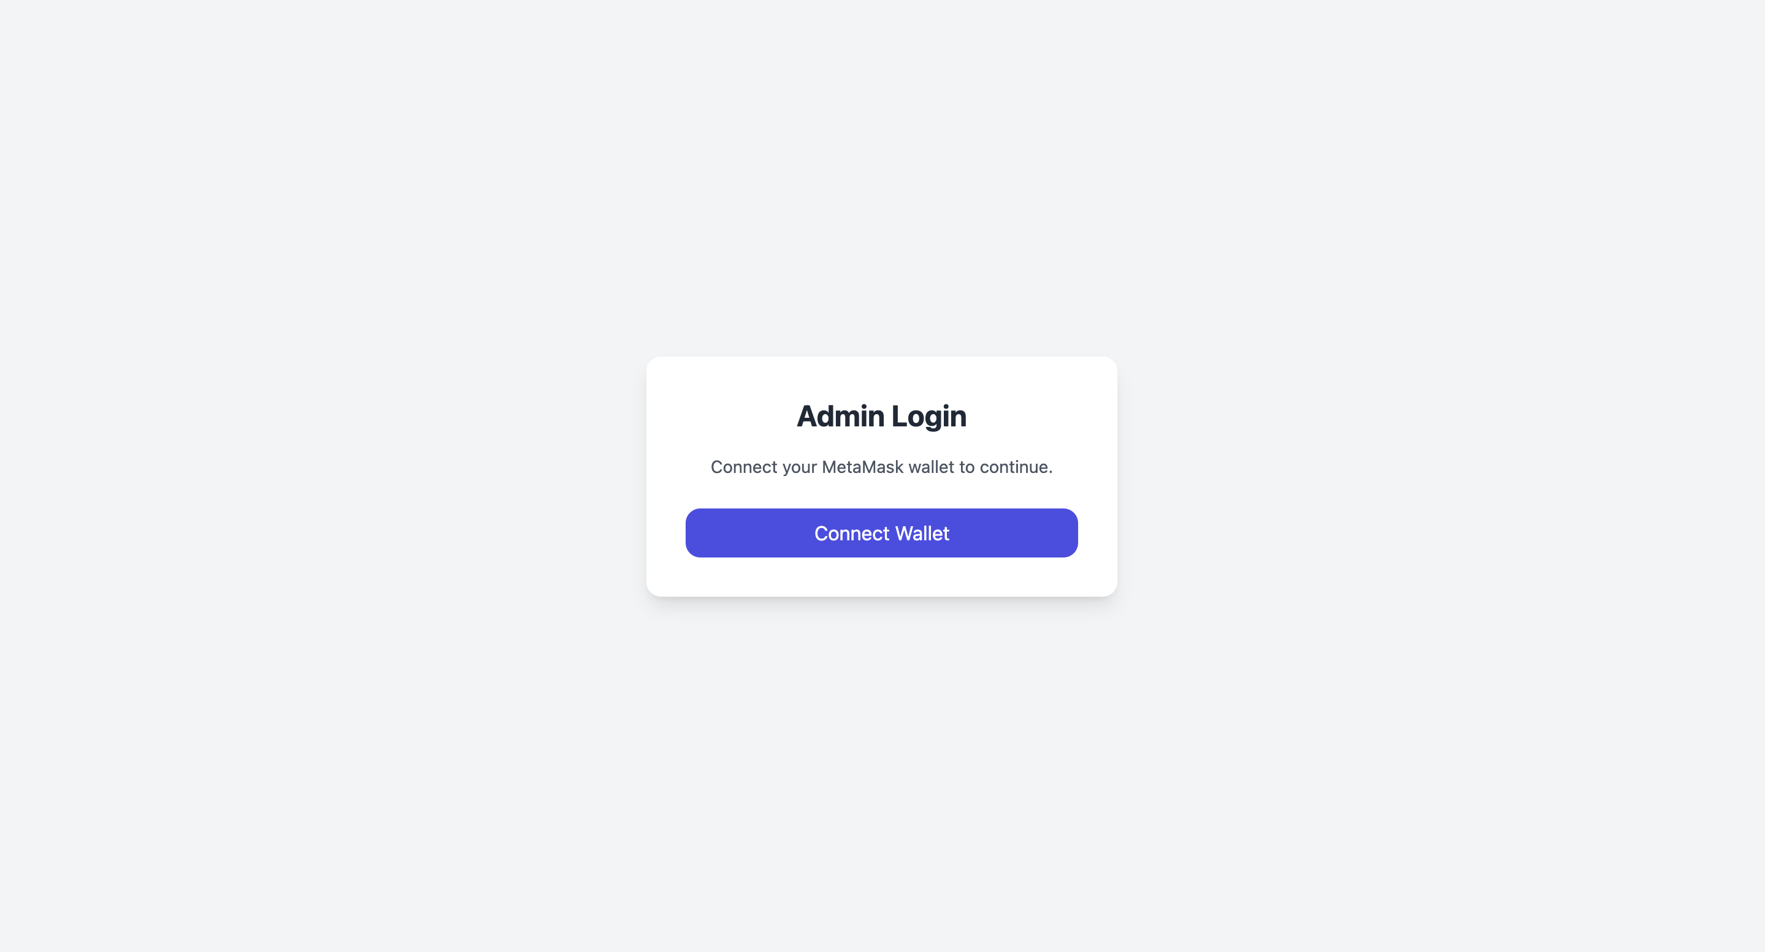
Figure 4.9.1.1: Admin Login / Wallet Connection Page

(b) Admin Dashboard
Displays election summary, voter statistics, and quick access to all administrative features.
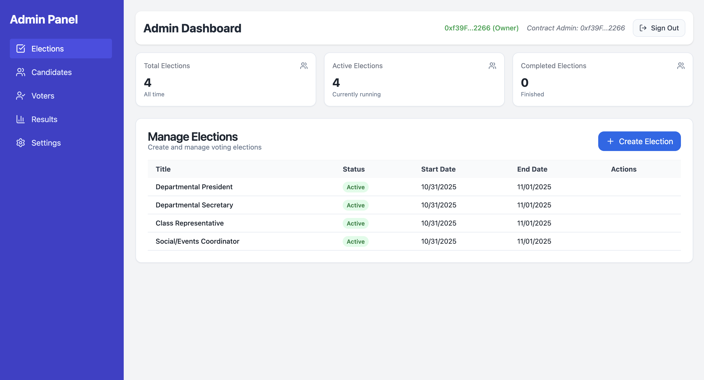
Figure 4.9.1.2: Admin Dashboard

(c) Create Election Page
Enables the admin to create new elections by providing title, description, and start/end dates.
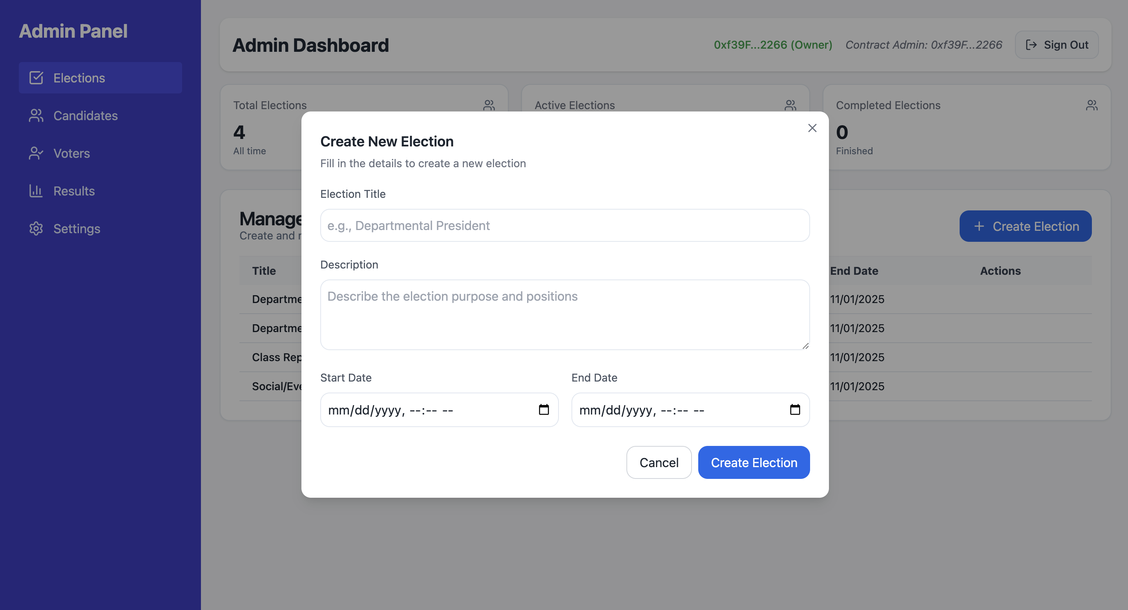
Figure 4.9.1.3: Create Election Page
(d) Add Candidates Page
Allows the admin to add or manage candidates for a specific election.

Figure 4.9.1.4: Add Candidates Page

(e) Verify Voter Page
Displays registered voters and allows admin to verify or revoke verification.
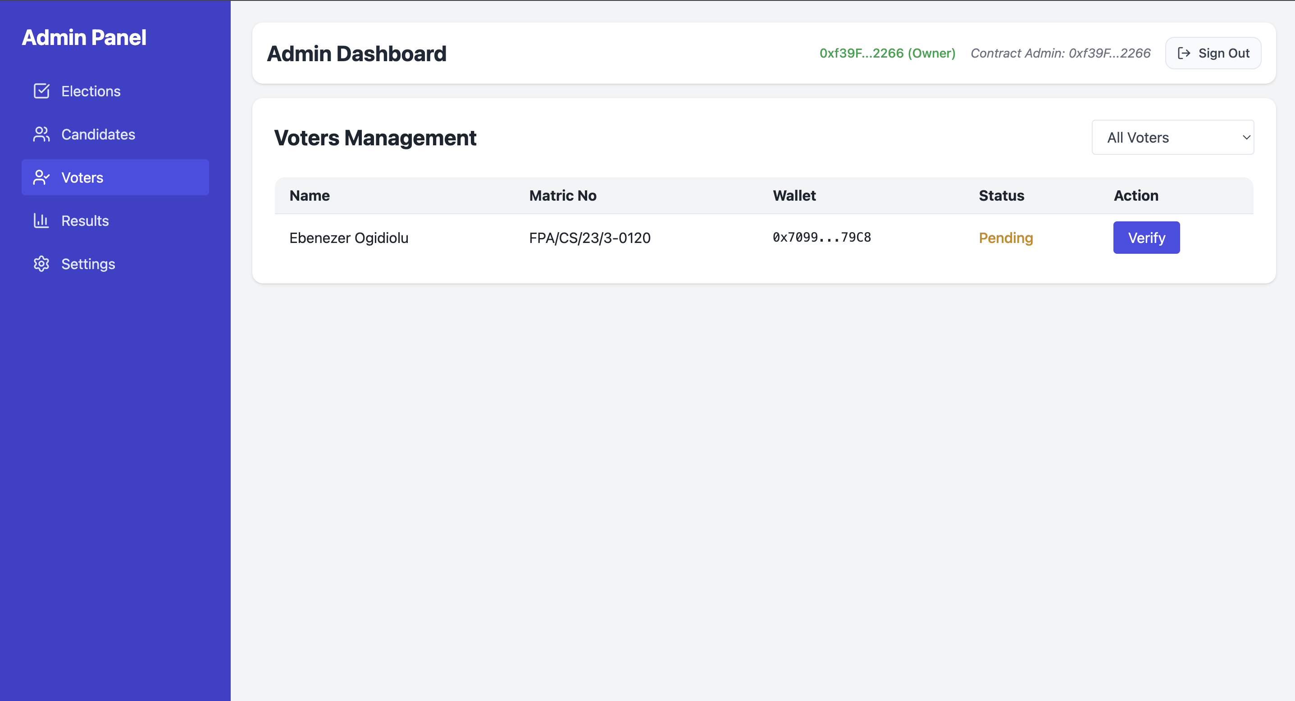
Figure 4.9.1.5: Verify Voter Page

(f) View Results Page
Lets the admin view election results in real time after the voting period ends.

Figure 4.9.1.6: View Results Page

4.9.2 VOTER INTERFACES
These interfaces are for registered voters interacting with the blockchain to cast votes.
(a) Voter Login / Wallet Connection
Voter connects their MetaMask wallet to the application.
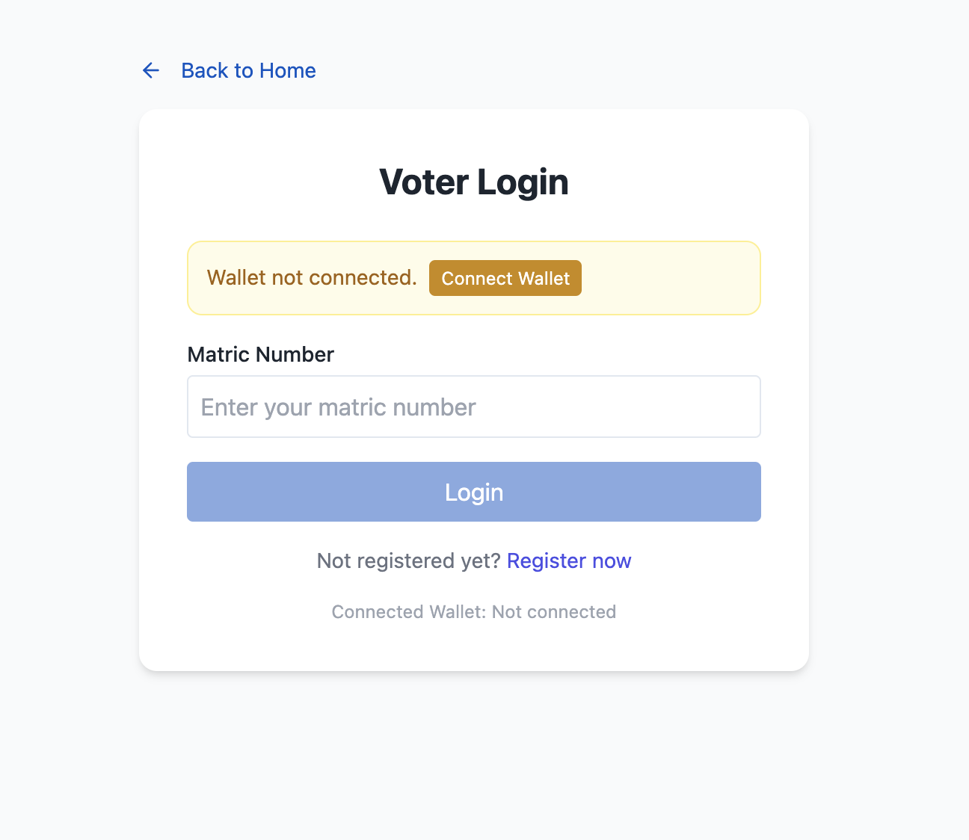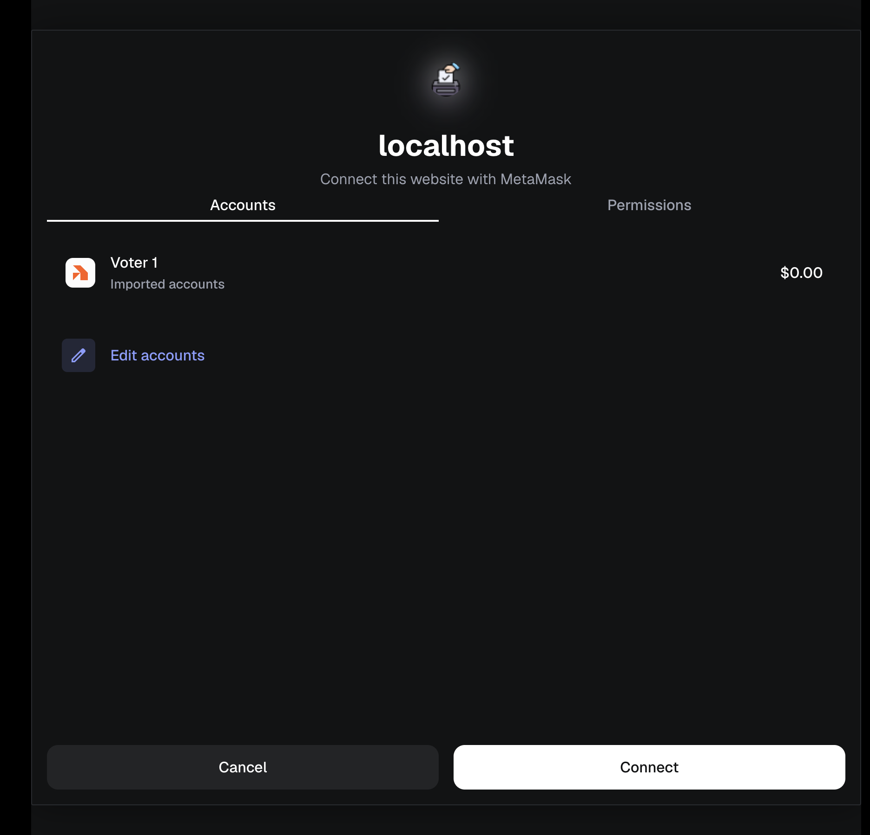
Figure 4.9.2.1: Voter Login / Wallet Connection
(b) Voter Registration Page
Allows voters to register with their name, matric number, and wallet address.

Figure 4.9.2.2: Voter Registration Page

(c) Voter Verification Status
Displays verification state (verified or pending) as updated by the admin.

Figure 4.9.2.3: Voter Verification Status

(d) Election List Page
Shows all available elections that the voter can participate in.

Figure 4.9.2.4: Election List Page

(e) Voting Interface
Displays candidate list with their details and allows the voter to select one and cast a vote.
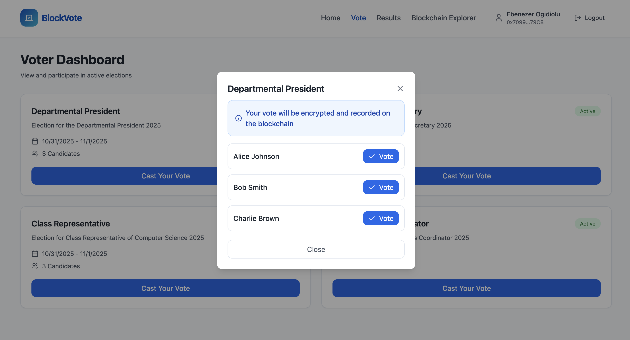
Figure 4.9.2.5: Voting Interface
(f) Vote Confirmation Popup
Displays confirmation after successful transaction via MetaMask. 
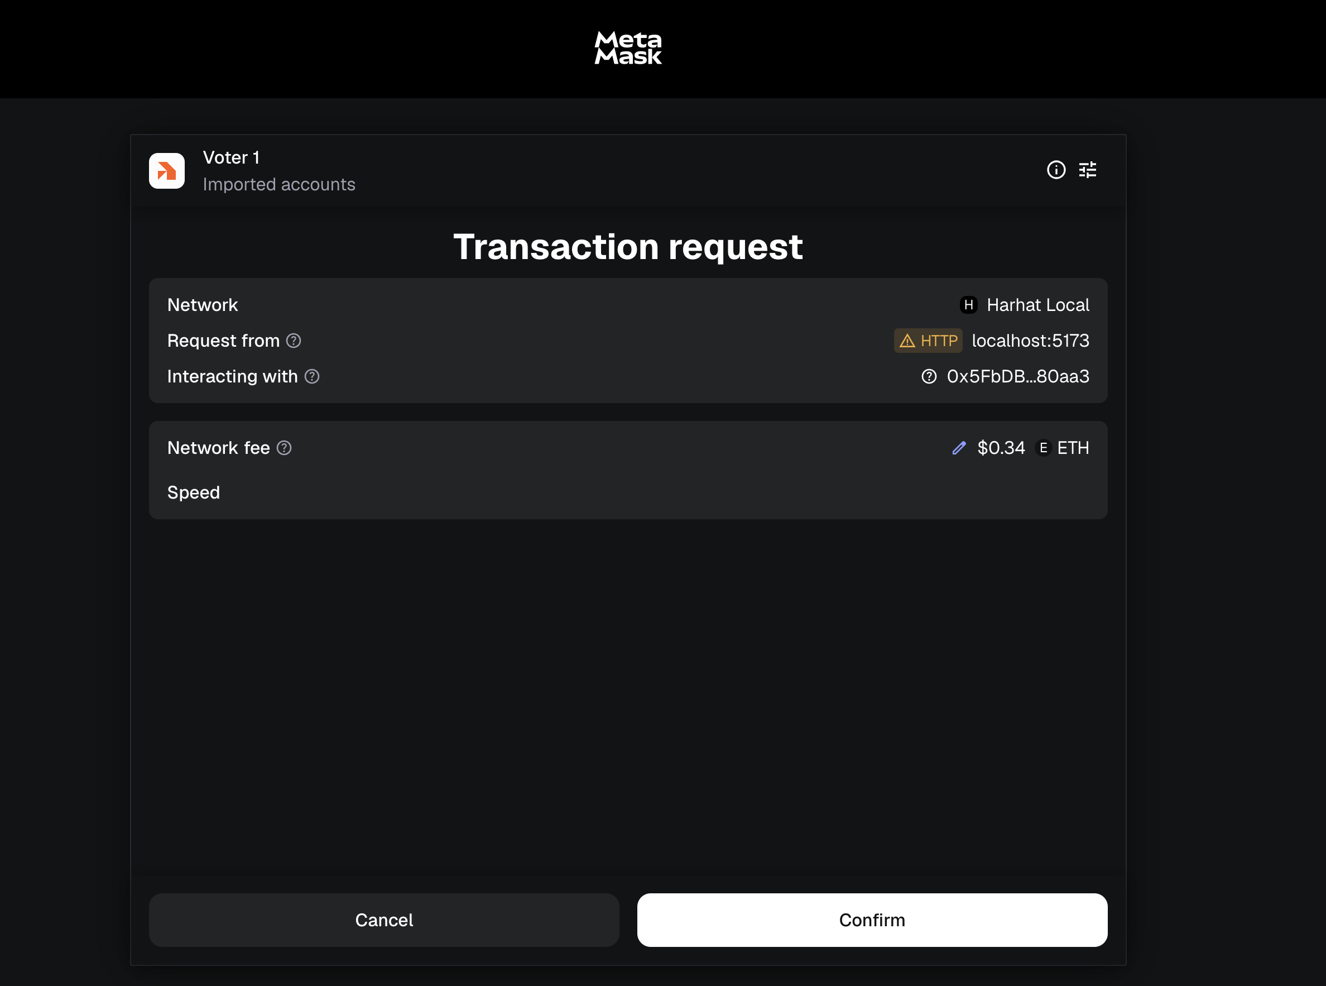
Figure 4.9.2.6: Vote Confirmation Popup
(g) View Election Result
Allows the voter to view the final results after the election closes.
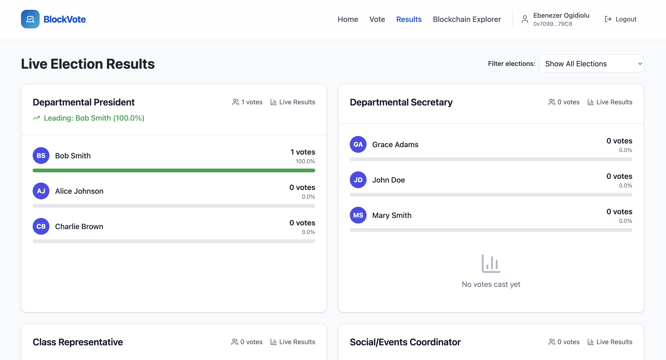
Figure 4.9.2.7: View Election Result

4.9.3 SMART CONTRACT DEPLOYMENT INTERFACE (OPTIONAL BUT RECOMMENDED)
To demonstrate the blockchain implementation layer of the system.
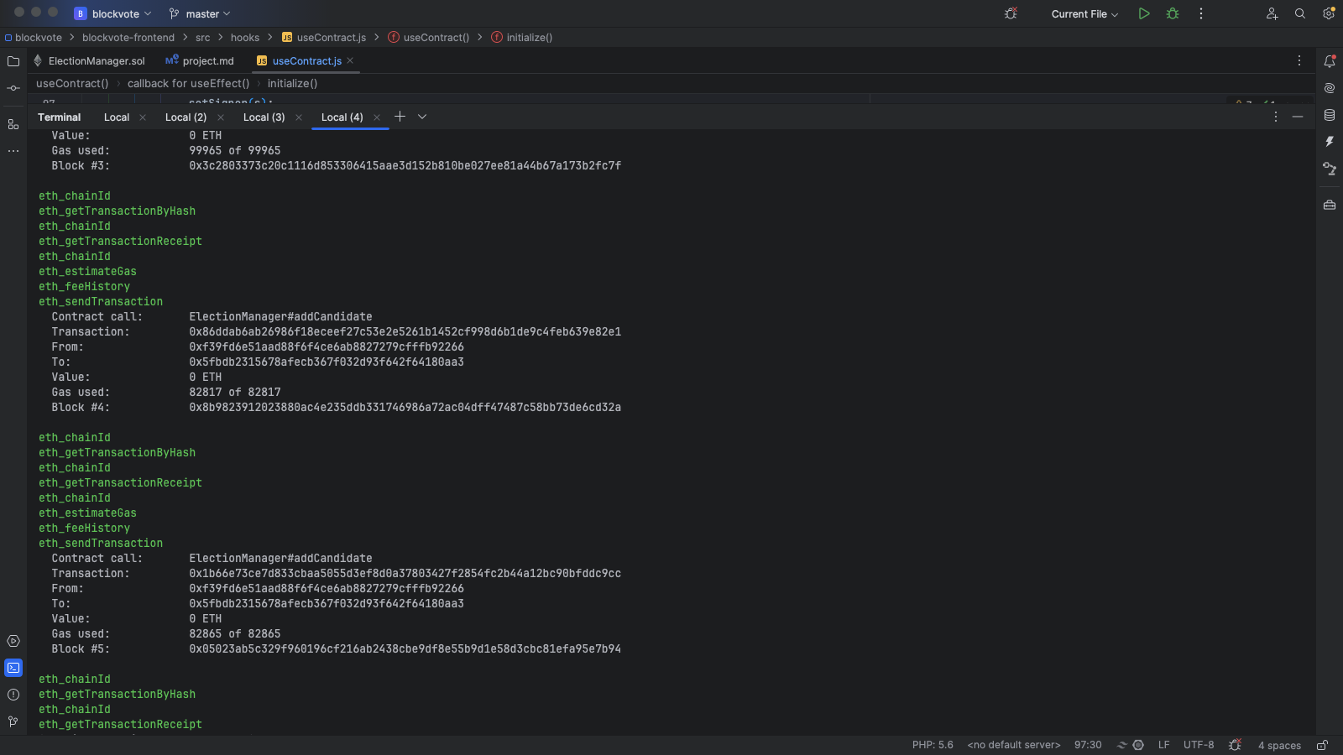
Figure 4.9.3.1: Smart Contract Deployment Interface (Optional But Recommended)

4.9.4 META MASK TRANSACTION PROMPT
To validate that blockchain transactions require wallet authorization.
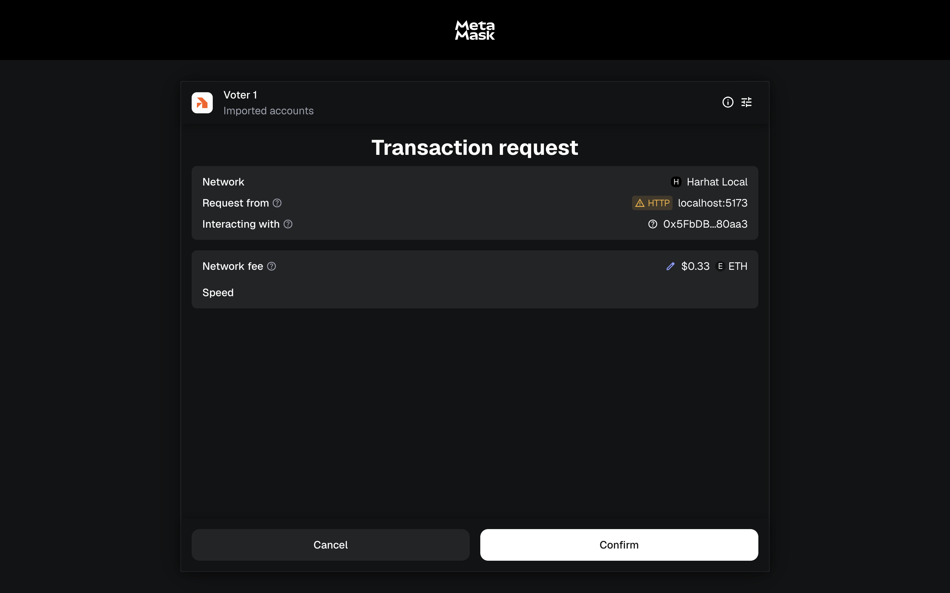
Figure 4.9.4.1: Meta Mask Transaction Prompt

4.10 SYSTEM REQUIREMENTS
The system requirements define the minimum and recommended specifications needed for the proper installation, development, and execution of the Blockchain-Based Electronic Voting System. These requirements ensure smooth interaction between the smart contracts, blockchain network, and the user interface.

4.10.1 Hardware Requirements
The minimum hardware specifications required to deploy or run the system are:
- Minimum 500GB SSD or HDD storage
- Intel Core i5 (1.8 GHz or higher) or AMD equivalent processor
- Minimum 8GB RAM (16GB recommended for local blockchain development)
- 1080p display or higher
- Standard keyboard and mouse
- Stable internet connection (for blockchain and wallet synchronization)

4.10.2 Software Requirements
The software environment required for the system includes:
- Operating System: Windows 10/11, macOS, or Linux (Ubuntu preferred for development)
- Node.js (v18 or above): for running React and Hardhat scripts
- npm or yarn package manager: for dependency installation
- Hardhat development environment: for smart contract deployment and testing
- MetaMask browser extension: for wallet connection and transaction signing
- React.js (v18 or above): for the frontend interface
- Ethers.js library: for interacting with the deployed smart contract
- Code editor (e.g., Visual Studio Code): for development
- Web browser (Google Chrome, Brave, or Firefox): with Web3 wallet support

4.10.3 Running and Accessing the Program
Since the application is web-based and blockchain-integrated, it can be accessed through the following means:

Localhost Deployment (Development Mode):
- Start a local blockchain network using Hardhat with the command:

- Deploy the smart contract:
- Navigate to the frontend directory and run:
- Access the application via the browser at: http://localhost:5173 (or assigned port).
- Web Hosting (Production Mode):
- The frontend build can be hosted on platforms like Vercel, Netlify, or GitHub Pages.
- The smart contracts can be deployed to a public blockchain testnet (e.g., Sepolia, Goerli) using:
- The hosted app should connect to the deployed contract address using MetaMask.

4.11 CHANGEOVER STRATEGY
A parallel changeover strategy is recommended for system deployment. This involves running the new blockchain-based e-voting system concurrently with the existing manual or web-based voting system for a specific trial period. During this time, both systems operate in tandem to validate the blockchain system’s integrity, transparency, and performance. Once confirmed stable and reliable, the old system can be gradually phased out.
This approach minimizes risk, ensures user confidence, and allows for proper testing of wallet connections, contract execution, and transaction confirmations in real-world conditions.

CHAPTER FIVE

SUMMARY, CONCLUSION AND RECOMMENDATIONS

5.1 SUMMARY
This study presented the design and implementation of a Blockchain-Based Electronic Voting System, built using Solidity, Hardhat, React, and MetaMask. The system was developed to address critical issues in traditional electoral processes such as voter impersonation, ballot manipulation, and result tampering.
The smart contract written in Solidity automates election operations such as voter registration, candidate management, and vote casting, ensuring transparency and immutability of results. Hardhat was employed for smart contract compilation, deployment, and testing, while the React.js frontend provided a user-friendly web interface that interacts with the blockchain through MetaMask wallet integration.
This implementation demonstrates the potential of blockchain technology to revolutionize election management systems by eliminating centralized control, increasing trust, and providing a transparent audit trail of every vote cast. The system proves that blockchain can effectively serve as a secure, decentralized, and verifiable voting platform for institutions and national elections alike.

5.2 CONCLUSION
The developed blockchain-based e-voting system validates the effectiveness of using distributed ledger technology (DLT) to achieve secure and transparent digital elections. Through the integration of smart contracts, votes are stored immutably on the blockchain, ensuring that they cannot be altered or deleted after submission.
By leveraging MetaMask for authentication and React for an interactive user interface, the project demonstrates the practicality of combining web technologies with decentralized architectures to solve real-world governance problems.
This project concludes that blockchain can serve as a dependable backbone for future voting systems, especially in developing countries like Nigeria, where election credibility has long been a concern. Its transparency, security, and decentralization make it a suitable replacement for traditional paper-based and centralized electronic systems.

5.3 RECOMMENDATIONS
In line with the objectives of the Department of Computer Science, the following recommendations are proposed for academic, research, and institutional advancement:
- Academic Integration and Research Expansion:
- The Department of Computer Science should incorporate Blockchain Technology and Smart Contract Development into the curriculum, allowing students to gain hands-on experience in emerging technologies that drive digital transformation.
- Further research should be encouraged on advanced consensus algorithms, Layer 2 scalability, and zero-knowledge proofs (ZKPs) to enhance security and performance in blockchain voting systems.
- Institutional Deployment and Testing:
- Universities and other academic institutions should pilot blockchain-based voting systems for student union elections and departmental decision-making. This provides a controlled environment to test and refine the system before real-world governmental adoption.
- Collaboration with Industry and Government:
- The Computer Science Department should collaborate with tech companies, blockchain research hubs, and electoral bodies to improve interoperability between academic research and real-world implementation.
- Partnerships can help secure research grants and blockchain nodes for institutional deployment and simulation studies.
- Enhanced Security and Identity Verification:
- Future research should focus on integrating biometric verification systems (such as facial or fingerprint recognition) with blockchain identity management to prevent duplicate or fake voter registrations.
- Performance and Scalability Improvements:
- The system can be optimized to use sidechains or Layer 2 solutions (e.g., Polygon, Arbitrum) to handle large-scale elections efficiently, minimizing transaction fees and latency.
- Knowledge Dissemination and Capacity Building:
- Regular workshops, hackathons, and seminars should be organized by the Department to expose students and researchers to blockchain application development using Solidity, Hardhat, and decentralized frameworks.

REFERENCES
- Song, J. G., Moon, S. J., & Jang, J. W. (2021). A scalable implementation of anonymous voting over ethereum blockchain. Sensors, 21(12). https://doi.org/10.3390/s21123958
- Razu Ahmed, M., Javed Mehedi Shamrat, F. M., Asraf Ali, M., Rajib Mia, M., Javed Mehedi Shamrat, F., & Arifa Khatun, M. (2020). The Future of Electronic Voting System Using Blockchain. Article in International Journal of Scientific & Technology Research, 9, 2. www.ijstr.org
- Shah, A., Sodhia, N., Saha, S., Banerjee, S., & Chavan, M. (2020). Blockchain Enabled Online-Voting System. ITM Web of Conferences, 32, 03018. https://doi.org/10.1051/itmconf/20203203018
- Khoury, D., Kfoury, E. F., Kassem, A., & Harb, H. (2018, July 2). Decentralized Voting Platform Based on Ethereum Blockchain. 2018 IEEE International Multidisciplinary Conference on Engineering Technology, IMCET 2018. https://doi.org/10.1109/IMCET.2018.8603050
- Casimir, A., Omeh, E., & Ike, C. (2013). Electoral Fraud in Nigeria: A Philosophical Evaluation of the Framework of Electoral Violence. Open Journal of Political Science, 03(04), 167–174. https://doi.org/10.4236/ojps.2013.34023
- McCorry, P., Shahandashti, S. F., & Hao, F. (2017). A smart contract for boardroom voting with maximum voter privacy. Lecture Notes in Computer Science (Including Subseries Lecture Notes in Artificial Intelligence and Lecture Notes in Bioinformatics), 10322 LNCS(December), 357–375. https://doi.org/10.1007/978-3-319-70972-7_20
- Understanding Kaduna electronic voting system as state makes history. (2022). https://www.premiumtimesng.com/features-and-interviews/268084-explainer-understanding-kaduna-electronic-voting-system-as-state-makes-history.html
- History of Blockchain. (2022). https://www.javatpoint.com/history-of-blockchain
- Blockchain Definition: Everything You Need To Know. (2022). https://101blockchains.com/blockchain-definition/
- Mattila, J. (2016). The Blockchain Phenomenon The Disruptive Potential of Distributed Consensus Architectures. ETLA Working Papers, 38(February), 26.
- McCorry, P., Shahandashti, S. F., & Hao, F. (2017). A smart contract for boardroom voting with maximum voter privacy. Lecture Notes in Computer Science (Including Subseries Lecture Notes in Artificial Intelligence and Lecture Notes in Bioinformatics), 10322 LNCS(December), 357–375. https://doi.org/10.1007/978-3-319-70972-7_20
- Mikail, O., Oladiran, O., Arulogun, T., Omidiora, E. O., & Oludotun, A. (2013). Design of Secure Electronic Voting System Using Multifactor Authentication and Cryptographic Hash Functions. International Journal of Computer and Information Technology, February, 2–06. www.ijcit.com
- Muse, S. A., & Narsiah, S. (2015). Challenges to Public Participation in Political Processes in Nigeria. Journal of Social Sciences, 44(2–3), 181–187. https://doi.org/10.1080/09718923.2015.11893477

APPENDIX
